Lesson 7 – Collaborative Editing
 | Objectives
In this lesson we will:
- Introduce the idea of Wiki ethics,
- Explore the Recent changes page,
- and diff & history links,
- Learn how to Revert to previous versions
Creating educational content on WikiEducator is quite different from what you may be used to. WikiEducators' contributors may come from many different countries and cultures and have different views, perspectives, and backgrounds, sometimes varying widely. Treating others with respect is the key to collaborating effectively in building useful resources on WikiEducator. Remember that all resources on WikiEducator are viewable and potentially editable by anyone who creates an account. Expect your work to be edited by others and resolve any disputes or leave comments by using the Discussion pages.
Our work is based on a consensus model. In practice members of WikiEducator agree to work as follows:
- Draft plans, outlines and suggestions are created on the wiki. Anyone is free to create a new wiki page in relation to any content.
- Consensus discussions take place in the Discussion pages (i.e. the Discussion or User talk tabs you will find above the content area of each page).
- Once consensus is achieved, please make the necessary changes on the relevant wiki page.
- Minor edits, improvements and new additions are usually done without discussion.
The Recent Changes page lets you see the most recent edits made to pages in WikiEducator. Using this page, users can monitor and review the work of other users, allowing mistakes to be corrected and to track where activity is occuring. There is a link to the Recent Changes page in the sidebar of each page.

Understanding Recent Changes
- (diff) (hist) . . Online_manual; 10:06 . . Mackiwg (Talk) (Added link to glossary)
- (diff) (hist) . . N Wikieducator tutorial; 10:06 . . Brent Simpson (Talk) (New tutorial)
The two lines above are an example of the kind of text that you would see if you click on the Recent changes link in the navigation box on the left of this page. The text shows two edits: the first by a user called Mackiwg who added a link to the glossary on the eXe Online manual page; and the second by user BrentSimpson who has created a new page called the Wikieducator tutorial.
From left to right here's whats going on in the above sample of the Recent changes:
- "diff" links to the diff-page for this edit (more on diffs in the next section).
- The "hist" link corresponds to the history link on the edited page: it shows not just this edit but also older and newer ones to this page.
- A bold N indicates that the page is "new", i.e., previously did not exist.
- A bold m would indicate that the user marked the edit "minor".
- The next link is a link to the current version of the page in question.
- 10:06 refers to the time in UTC. You can change the time to your time zone using your user preferences.
- For logged in users, the next link is a link to their user homepage (as usual with internal links, the view page if the page exists, the edit page if it does not, the two being styled differently).
- Finally, there is a link to the user's talk page (the same remarks regarding existence apply).

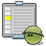 | Activity
Let's take a look at how this function works.
- Open a new tab or browser window (this will allow you to switch between this tutorial and another window where you can practice using the tools while still having access to these instructions.)
  - To open a new tab or browser in IE7 and Mozilla Firefox, click File>New Tab or Ctrl/Command T.
- To switch between tabs, click Ctrl Tab or Ctrl Pg Up/Down.
- In your new tab window, go to http://WikiEducator.org
- Click on the Recent Changes link in the navigation menu to the left of this screen and take a look at some of the changes that have been made recently. (Use the back arrow to move back between pages as you click on the various links on this screen to see what changes have been made.)
- Once you are a little more familiar with this return to the tutorial either clicking on the tab for your "Wikieducator" window at the top of the screen or by clicking Ctrl Page Up.

History
All editable pages on WikiEducator have an associated page history, which lists all changes made to the page in reverse-chronological order. You can access this information by clicking on the history tab that is located at the top of every page. Viewing the history of a page is kind of like looking at the recent changes, but in this case the changes are just for this page.

Diffs
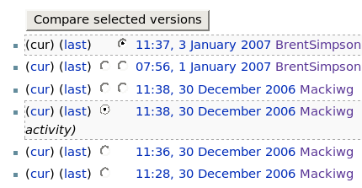
the "history" page. The radio buttons designate which versions of changes will be compared when you hit the Compare selected versions button.
The history page also allows you to compare changes between one edit of the page and others. A diff is the difference between two versions. It can be viewed by clicking the page history tab at the top of every page. For every version or change that has been made to the page there are potentially two radio buttons: the left column is for selecting the older version, the right column for selecting the newer one. Pressing "Compare selected versions" gives the difference between the two versions.

Activity
Take a look at the history of this page by clicking on the history tab above. Select the versions you want to compare by clicking the radio button beside each and click on the compare changes button at the top or bottom of the list.

If you have completed the above Activity you would have noticed a screen that looked similar to this:
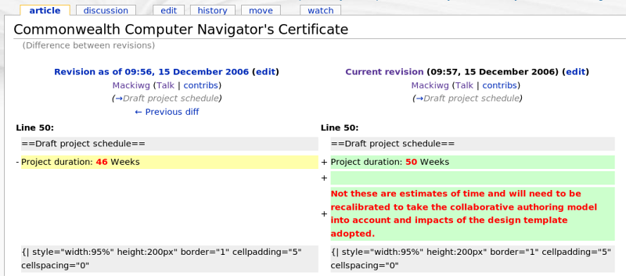the "diff" page after hitting the Compare selected versions button.
The right hand side displays the most current version of the page, while the left shows the previous state. From this diff we can see that the user (Mackiwg) changed Line 50 from reading 46 Weeks to 50 Weeks and also added a note about how the project duration was estimated.
Viewing the diff between two versions of a page is the best way to get a detailed view of what exactly has been changed on a page.To revert a page is to undo all the changes made to that page after a specific time in the past. The result will be that the page becomes identical in content to the page as it was saved at that time. Reverting is a decision which should be taken seriously and is primarily used for fighting vandalism. If you are not sure whether a revert is appropriate, discuss it first using the discussion or talk pages rather than immediately reverting or deleting it. If you feel an edit is unsatisfactory, try improving it rather than simply reverting or deleting it.
To revert a page to an earlier version:
- On the page you wish to revert, click on the History tab. Then click on the time and date of the earlier version you intend to revert to. It will not work if you click on 'cur', 'last', or "Compare selected versions".
- When the page displays, text similar to this: (Revision as of 15:35, 21 December 2006;), will display at the top of the page below the page's title.
- You can navigate backwards or forwards through the chronology of changes by using the '←Older revision | Current revision | Newer revision→' links.
- Verify that you've selected the desired former version of the page, then click a link to edit the page as you would normally.
- You'll get a prominent warning, displayed above the edit box, about editing an out-of-date revision.
- Ignore this warning and save the page. Be sure to add the word "revert" (or "rv") to the edit summary.

Activity
Pseudo Vandalism - Testing the revert feature
In this activity you will attempt a "vandal" entry on your User page and correct this using the revert feature.
NB: You must make sure that this activity is done on your own User page
- Make sure you're logged in and go to your user page. (Click on your User name after the image at the very top of any page).
- Click on the edit tab so you can make a change on your user page. Make sure that you are on your user page. You should see the heading: User:<your user name here>
- Enter the following text: "This is a dummy vandal entry"
- Click on the "Save page" button. You should now see your pseudo vandal entry on your user page.
- Now click on the history tab or link above the content area of your User page
- Check that the two most recent edits are highlighted in the radio buttons on the history page. Then click on the "Compare Selected Versions" button.
- Your most recent change, i.e. "This is a dummy vandal entry" should be displayed in red text.
- Click on the "previous diff" link above the left hand column on your page. This will take you back to the previous version of the page edit.
- You can preview to see whether the "vandal text" has been removed by scrolling down the page which will show the published view of the previous edit.
- Assuming you are happy with this version of the page, click on the "edit" link.
- Now click on the Save Page button without making any changes.
- Congratulations - you have now reverted your page back to a previous version, effectively removing your dummy vandal entry.

 | Summary
Creating content on a wiki can be a highly collaborative exercise that makes us interact with a variety of editors and authors from a wide range of backgrounds. Treating others with respect is key to this kind of authoring.
The wiki has a variety of tools that enable you to gain an overview of what kinds of edits are taking place across the entire wiki or within your own content pages. Checking the Recent Changes page often is a good way to get an overview of where activity is taking place in the wiki in general. To see what individual changes have been made to any page use the history link on that page. The diff function will help you locate these specific changes between versions of the page and if you need you can revert to any version in time. This way any 'vandalism' (although unlikely in WikiEducator) can be quickly removed.

