CREATE YOUR OWN DROODLE

- Draw some nice or funny or strange (or whatever) stuff .
(Do it in a computer-programme that allows you to paint painlessly, i. e. >Paint<.)
- Transfer your drawing onto the clipboard.
- Think about a funny (or/and far-fetched) explanation of your drawing.
- Create a perfectly formatted sheet of paper in your word-processing programme:
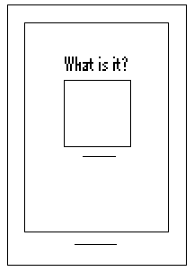
Title

Painting
Subtitle

Footer

Frame

Here are some hints and clues to the points above:
- Creating the drawing:
Use a programme for painting you are familiar with (i.e. >Paint<). It doesn’t need an awful lot of features. Keep your drawing as simple as possible.
- Transferring onto the clipboard:
Don’t forget to select your drawing. >Ctrl+C< does the transfer.
- Finding a subtitle (an explanation) to your drawing:
Think about a far-fetched idea. I wouldn’t go for the straight-forward solution.
- Creating the sheet:
It has to show:
- Title (>What is it?<)
- Drawing (>Crtl+V< does the transfer off the clipboard onto your sheet.)
- Subtitle (Do it in a very small font – i. e. 6 points!)
- Footer (It shows your name, your class, and the school-year.)
- Frame (Please, don’t overdo it!)

